(1). What do you understand by CSS opacity?

we can say that it specifies the clarity of the image.

.c8 {

    width: 144px;

    height: 90px;

    background-color: #00bec9;

    margin-top: 30px;

    margin-left: 385px;

    opacity: 0.2;



}

(2). How can the background color of an element be changed?

use the CSS background-color property. Set it to the color name or code we want and place it inside.

.ss {

    width: 184px;

    height: 35px;

    background-color: #daac00;



    margin-left: 80px;

    margin-top: 10px;

    background-image: url(imge/Instagram.png,imge/Facebook.png,imge/WhatsApp.png,imge/Twitter.png);

    background-repeat: no-repeat;

}

(3). How can image repetition of the backup be controlled?

use the background-repeat property. we can use no-repeat value for the background-repeat property.

background-image: url(imge/Instagram.png,imge/Facebook.png,imge/WhatsApp.png,imge/Twitter.png);

    background-repeat: no-repeat;



(4).What is the use of the background-position property?

The background-position property sets the starting position of a background image.

.eight {

    background-image: url(imge/ab.png);

    background-position: 100%;



    background-repeat: no-repeat;

}

(5). Which property controls the image scroll in the background?

The background-attachment property can either be set to scroll or fixed

. .eight {

    background-image: url(imge/ab.png);

    background-position: 100%;

    background-repeat: no-repeat;

    background-attachment: fixed;



}

(6). Why should background and color be used as separate properties?

The background property is a complex property in CSS, and if it is combined with color, the complexity will further increase.

(7) what are the benefits of using CSS

Using CSS, you can control the color of the text, the style of fonts, the spacing between paragraphs, how columns are sized and laid out, etc..

(8) What are the disadvantages of CSS?

Different levels of CSS i.e. CSS, CSS 2, CSS 3 are often quite confusing. There might be cross-browser issues while using CSS.

some styles sheet are supported and some are not.

(9). What is the difference between CSS2 and CSS3?

* **CSS2:-**

CSS2 was the second version of the CSS specification and was released in 1998. It introduced several important features for web styling, including:-

**1)Position :-**

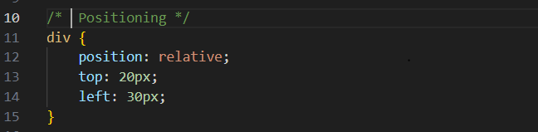

**2)Z-Index:-**

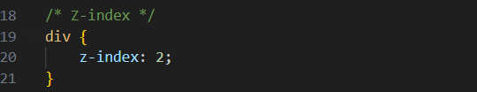

**3)Float:-**

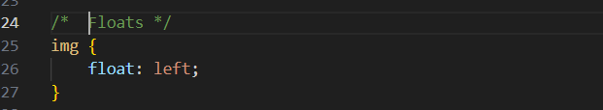

* **CSS3:-**

CSS3 is the latest version of the CSS specification, and it introduces even more features and enhancements. Some key features include:-

**1)Border Radius :-**

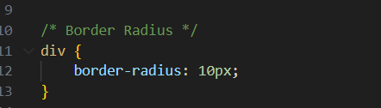

**2)Box Shadow :-**

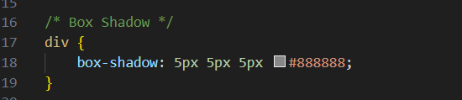

**3)Transition:-**

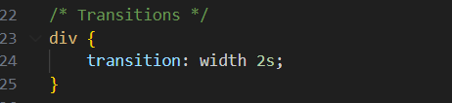

**4)Flexbox:-**

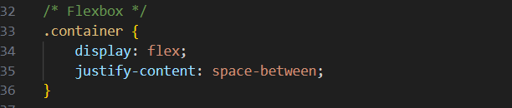

**5)Grid Layout:-**

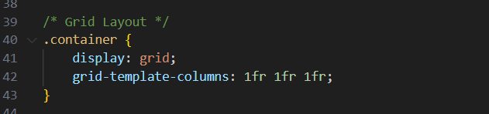

**6)Media Query:-**

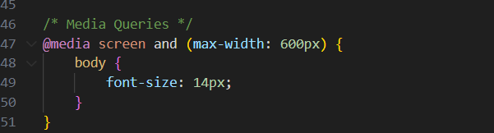

(10). Name a few CSS style components

1.Colors and Backgrounds: Setting background colors, images, gradients, and borders

.header {

    background-color: #f2f2f2;

    border-bottom: 1px solid #ccc;

  }

  .btn {

    background-color: #007bff;

    color: #fff;

    border: none;

    padding: 10px 20px;

  }

2.Flexbox and Grid: creating flexible and responsive designs

.container {

    display: flex;

    justify-content: space-between;

  }

  .grid-container {

    display: grid;

    grid-template-columns: auto

  }

3.Animations and Transitions: Adding movement or transitional effects to elements

.box {

    transition: transform 0.3s ease-in-out;

  }

  .box:hover {

    transform: scale(1.1);

  }

4Layouts: Controlling the layout of elements on a webpage using properties like display, float, position, etc.

.container {

    width: 80%;

    margin: 0 auto;

  }

  .box {

    float: left;

    width: 50%;

  }

5Typography: Styles for text including fonts, sizes, line heights, colors, and text decorations

body {

    font-family: Arial, sans-serif;

    font-size: 16px;

    color: #333;

    line-height: 1.5;

  }

(11). How to center block elements using CSS1?

Text Alignment:

If the block element contains text or inline elements, you can use text-align to center the content within the block element.

.centered-text {

    text-align: center;

  }

(12). How to maintain the CSS specifications?

Maintaining CSS specifications involves ensuring that your stylesheets adhere to the latest standards, considering browser compatibility, and organizing your code for readability and maintainability.

(13). What are the ways to integrate CSS as a web page?

Inline Styles:

Inline styles are added directly to HTML elements using the style attribute.

However, inline styles can make the HTML code less maintainableand harder to manage, especially in larger projects.

<div class="card mt-3 bg-success-subtle" style="width: 18rem;">

Internal Stylesheet:

Internal stylesheets are written within the <style> tag in the HTML document's <head> section.

</head>

<style>

  .card {

    height: 500px;

    width: 100%;

    align-items: center;

    color: chartreuse;

    margin-top: 100px;

    /* margin-left: 300px;  */

    display: flex;

    justify-content: center;

    align-items: center;

    border: none;

  }

External Stylesheet:

External stylesheets are separate CSS files linked to HTML documents using the <link> tag in the <head> section

  <head>

  <link rel="stylesheet" href="styles.css">

</head>

(14). What is embedded style sheets?

Embedded stylesheets, also known as internal stylesheets, refer to CSS styles.These styles are applied specifically to the HTML document in which they are defined.

<head>

  <meta charset="UTF-8">

  <meta name="viewport" content="width=device-width, initial-scale=1.0">

  <title>computers/sing in </title>

  <link href="https://cdn.jsdelivr.net/npm/bootstrap@5.3.2/dist/css/bootstrap.min.css" rel="stylesheet">

  <script src="https://cdn.jsdelivr.net/npm/bootstrap@5.3.2/dist/js/bootstrap.bundle.min.js"></script>

</head>

<style>

  .card {

    height: 500px;

    width: 100%;

    align-items: center;

    color: chartreuse;

    margin-top: 100px;

    /* margin-left: 300px;  */

    display: flex;

    justify-content: center;

    align-items: center;

    border: none;

  }

  .form-text {

    color: chartreuse;

    text-decoration: underline;

  }

  .card-body {

    background-image: url(download.jpeg);

    background-size: cover;

    background-repeat: no-repeat;

    border: 3px solid red;

  }

</style>

<body>

  <nav class="navbar navbar-light bg-light">

    <div class="container">

      <a class="navbar-brand" href="#">

        <img src="77489977-computer-lettering-design.jpg" alt="" width="100" height="50">

      </a>

    </div>

(15). What are the external style sheets?

External stylesheets refer to separate CSS files that are created independently from HTML documents and then linked to one or more HTML documents using the <link> element

you have a CSS file named styles.css

<html>

<head>

  <title>

  </title>

  <link rel="stylesheet" href="phone.css">

</head>

<body>

(16).What are the advantages and disadvantages of using external style sheets?

Advantages of External Style Sheet :-

• Consistency Across Multiple Pages

• Faster Page Loading

• Improve readability and Organization

• Reuse of Style

Disadvantages of External Style Sheet:-

• Possible Delay in Rendering

• Not Suitable for Singal-Use Style

• Dependency on External File

• Learning Curve for Beginners

(17). What is the meaning of the CSS selector?

a selector used to select and target HTML elements on a web page. Selectors allow you to define styles and apply CSS rules to specific elements or groups of elements.

.card-body {



    background-image: url(download.jpeg);

    background-size: cover;

    background-repeat: no-repeat;

    border: 3px solid red;

  }

(18). What are the media types allowed by CSS?

CSS provides several media types that allow you to apply styles based on the characteristics of the output device.

Example:-

• Screen:(‘screen’)

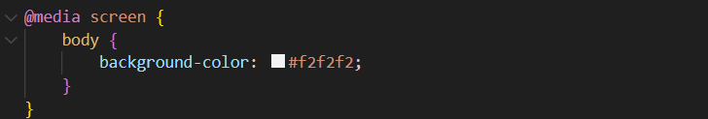

• Max Width:(‘max-width’)

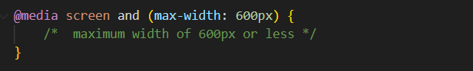

• Min Width:(‘min-width’)

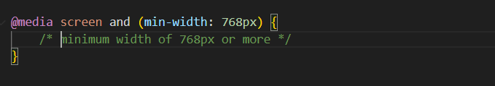

Q.19) What is the rule set?

a rule set is a combination of a selector and a declaration block.

Example:-

